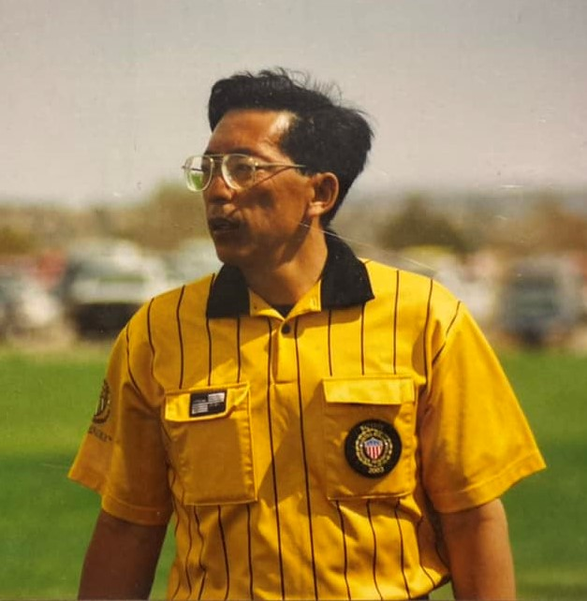

Paul Quan was born on January 26, 1954. Paul was the eldest of five children born to father, Yiu Lam, and mother, Lai Kuen. His parents were married in 1948 in Hoiping, China, before moving to Macau, where Paul was born. With the goal of meeting up with Paul’s paternal grandparents who had immigrated to the U.S., the Quan family made several moves during Paul's early years, starting in Macau, then moving to Hong Kong, before finally immigrating to Oakland, California in 1962.

Paul grew up in Chinatown in Oakland, California. He spent a great deal of time at Lincoln Square Park, where he and many of his classmates played recreational basketball and other outdoor sports. He was also a lifelong fan of Bay Area sports teams; he would always have a Warriors, Raiders, or A’s game streaming in the background. He graduated from Oakland Technical High School, where he met his future wife, Linda. Upon graduation in 1972, Paul attended the University of California at Berkeley. Go Bears! He was a member of the Air Force ROTC Program and would receive a Bachelor’s Degree in Computer Science in 1976 (when C.S. was still in its infancy and Paul would write his programs on punch cards). In 1982, he earned his Master’s Degree in Systems Management from the University of Southern California.

Paul will always be known as a man who never stopped working. He commissioned as a 2nd Lieutenant in the United States Air Force (Oct 1976) as a Communications Officer, and retired at the rank of Lieutenant Colonel (Sep 1997) from the Air Force Inspection Agency at Kirtland Air Force Base in Albuquerque, New Mexico. After an excruciating two months of retirement, he started his 2nd career at TVI/CNM - beginning in the Technologies Department and progressing to Executive Director of Academic Affairs.

Not only successful in career(s), Paul was able to create a fulfilling and happy home life. On September 11, 1976, Paul married his forever love and partner, Linda. Paul’s Air Force career would lead them all around the country. He was first stationed at Offutt Air Force Base in Omaha, Nebraska, where their first son, David, was born in 1977, followed by their eldest daughter, Tiffani, in 1980. Paul was then relocated to CA, where Kelli was born in 1982 and Kristi in 1986. Paul was eventually relocated to Washington DC, where he worked at the Pentagon. Their fifth and youngest child, Justin, was born in Maryland in 1988. In addition to his five immediate children, Paul was blessed with two grandchildren, Gavin and Gabrielle.

Outside of the office, Paul could be found out at the soccer fields. He played an active role with the National, Regional, and local soccer referee associations. He was an assessor, registrar, assignor, mentor, and once upon a time, he was seen on the field actually refereeing.

Paul maintained a handful of other hobbies and interests. Aside from the soccer field, one could find him at the bowling alley or the casino. He was also quite the collector; one could identify his territory by the stockpile of Star Wars and Coca-Cola merchandise, M&M’s and Jelly Belly candy dispensers, and various knickknacks including but not limited to rubber ducks, vintage electronics, and convention swag.

Paul unexpectedly passed away on September 17, 2022. He is survived by his wife Linda; children David Quan (Luka Smith), Tiffani Quan, Kelli Quan, Kristi Quan (Blake Clotfelter), Justin Quan; grandchildren Gavin Martin and Gabrielle Martin. He is also survived by his brothers, Henry and Kenny, and his sisters, Lily Tsang and Mary Buckley.

Paul will be missed by many and to honor his life, two celebrations are being planned - one in California (November 2022) and one in New Mexico (Spring 2023). More details will be announced once final arrangements are made. Although his final resting place will be in California, he can be remembered with every visit to the NM Soccer Complex in Bernalillo as the referee building is being named in his honor.
The celebration of life in California will be held on Sunday, November 6, in Elk Grove. To aid in preparation, for those wishing to attend, please reach out to Kelli Yukiko Quan-Martin or email NMSoccerRef@aol.com for more details.

